**Commitment Of Traders**

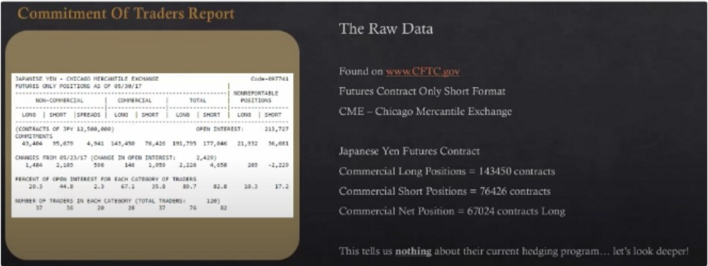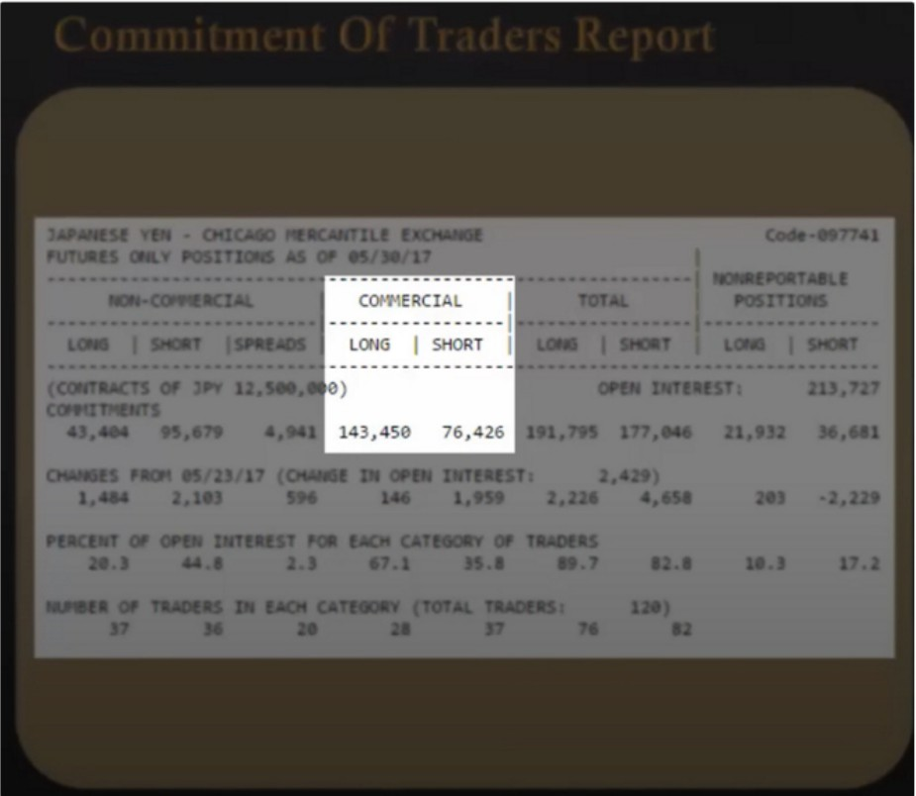

Only look at the futures contract, options is not for us CFTC.gov

Positive number is net long, negative number is net short This tells us nothing so far, we have to look deeper

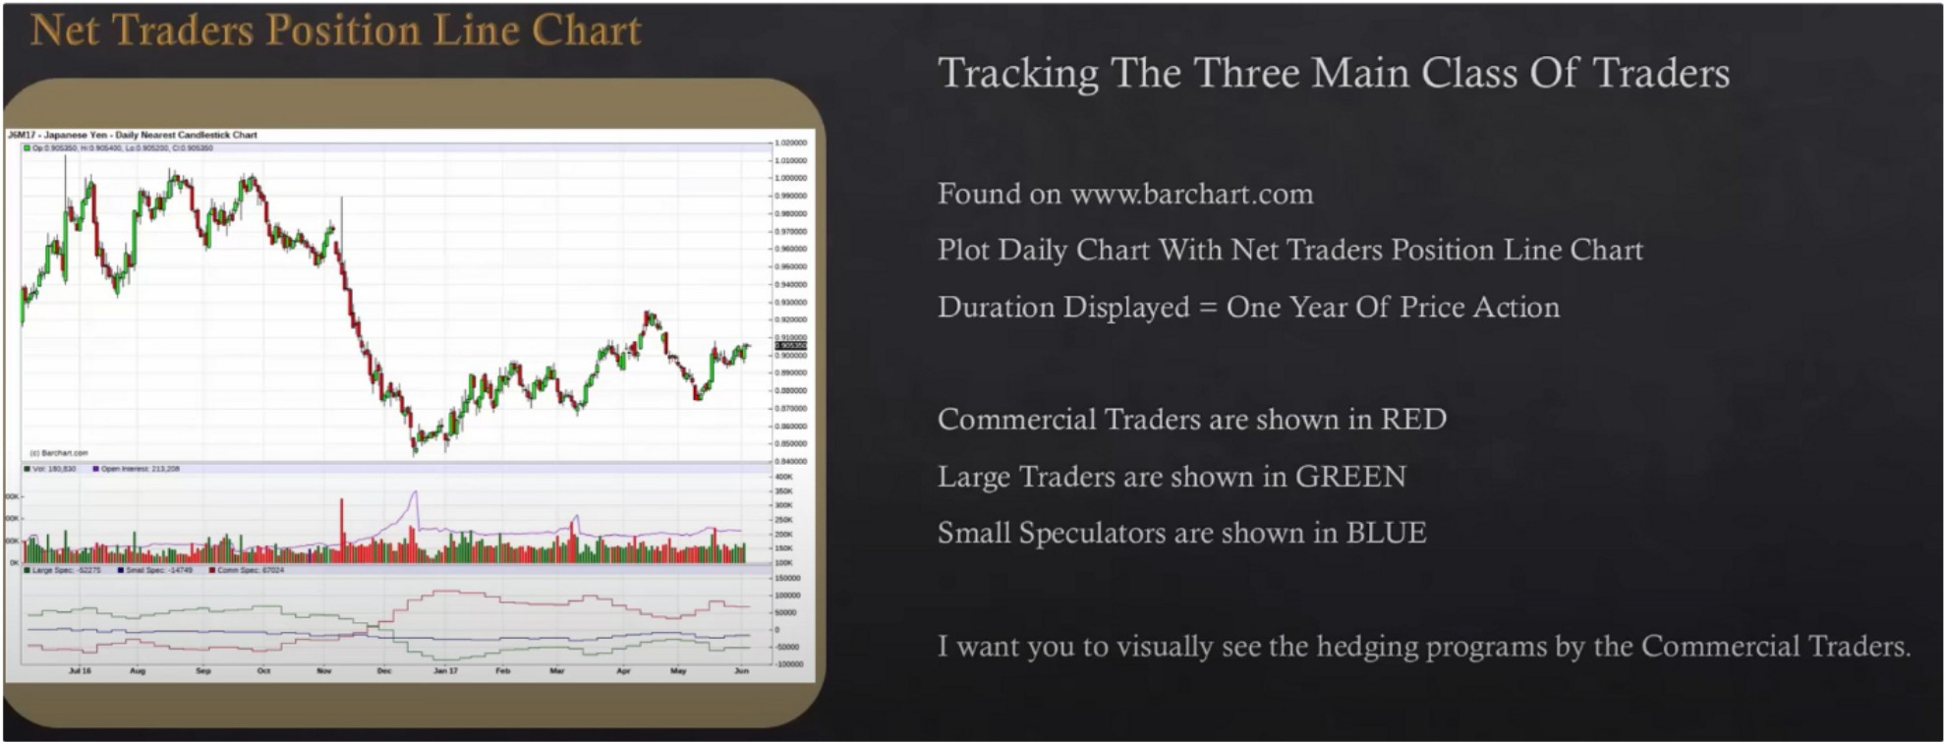

For COT hedging program we focus on the commercial traders, the red line Currencies are a commodity

When looking at the chart it give us an overall net basis

If the commercial traders think a commodity will rise in the futue they will heavily buy because they know its going up in the future, they do the same thing with commodities

Commodities also have more of a supply and demand factor

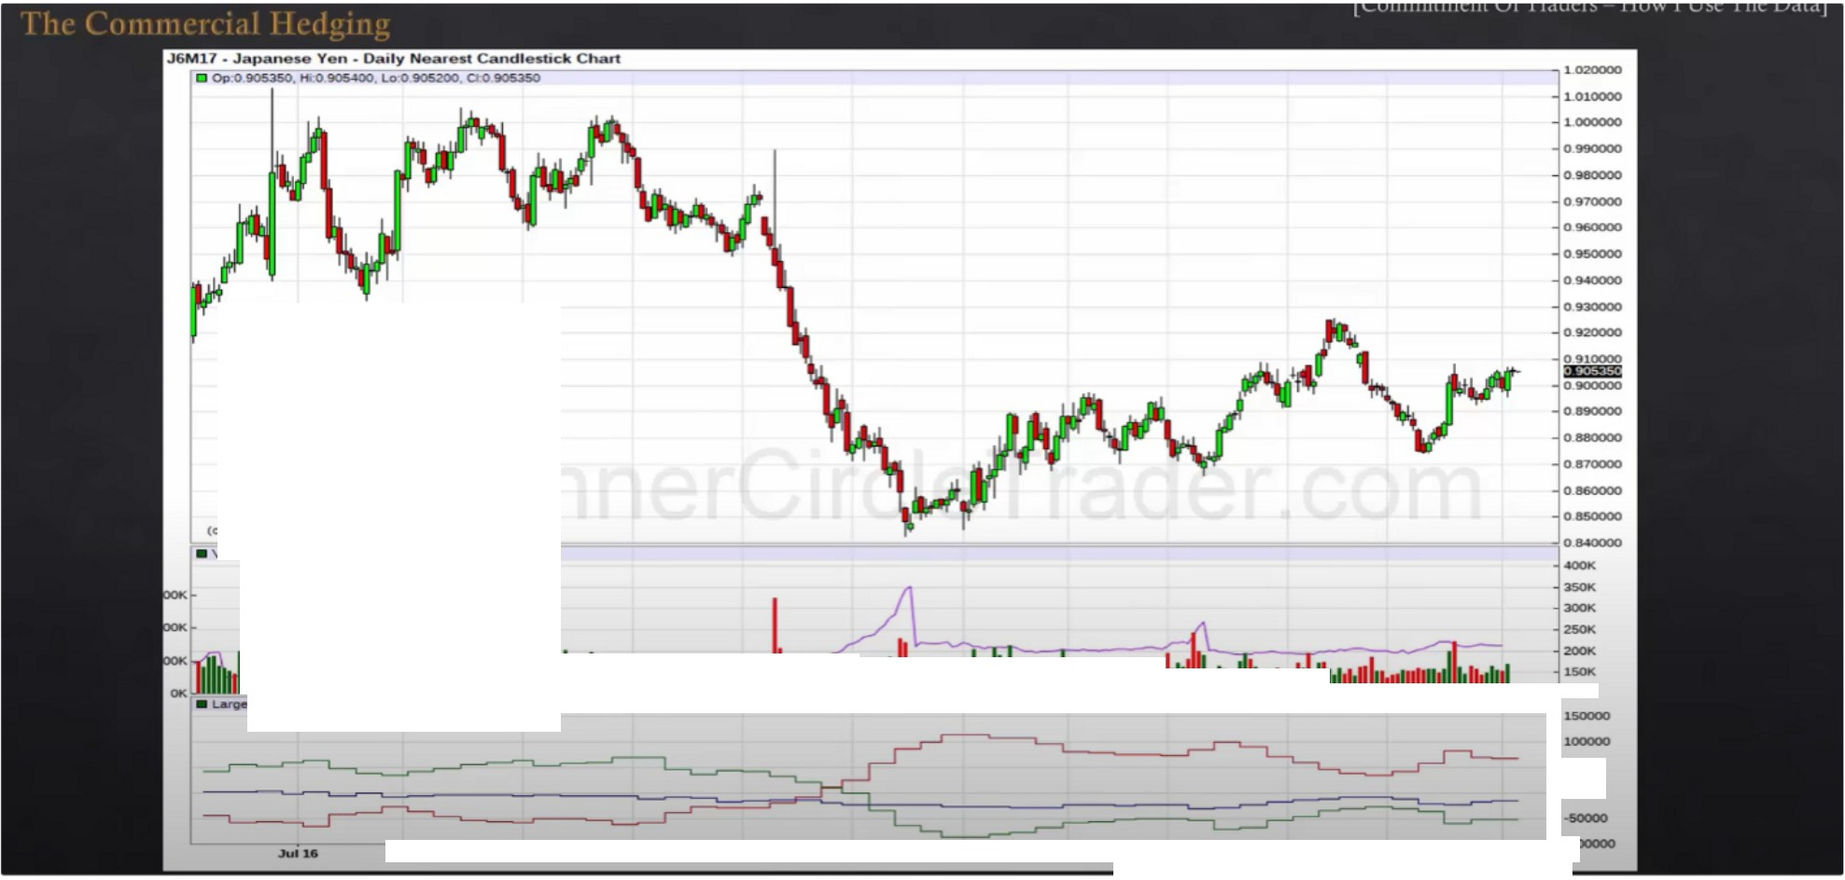

**ol.180.830 - "-Hl.2U.20S**

**J..••r**■**1i1J.•.-•1 •w•liliAiliiiliDi1aiiiiiiiiiiii.tliilli**

**••11111111111111110o111••**

·-

-- ---··· - -- . . . . . l:

....

--

Oel

-

-

,_

,..,,,,

.....

If the red line is above the O line, then commercials are net long

By itself it means theyre in a buy program, theres a buy program and a hedging program

Buy program is a macro program where they focus the bulk of their on buying they'll be selling some but they will be hedging in prices by selling

Shorter term buy program can be see by looking at the 12 to 6 month duration, we look back a year to see the highest net long position and the lowest net long position and the highest net short position and the lowest net short position

So we break the data into 2 parts, above the O line and below it. Above is a buy program and below it is a sell program, but theres also hedging that we need to be aware of and we can track that by using this information

Large speculators: big traders with a lot of equity

Small speculators: small money, people that have no idea whats going on Commercial speculator: banks/institutions

We only care about the red line

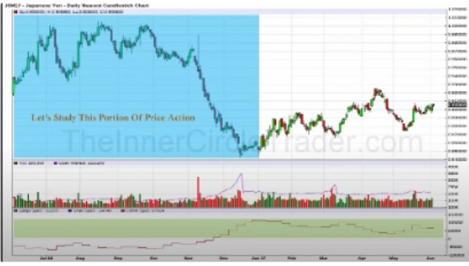- =

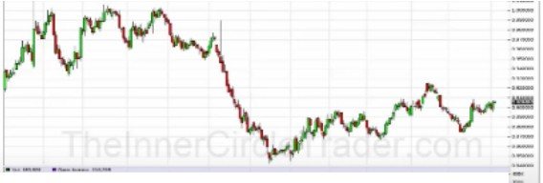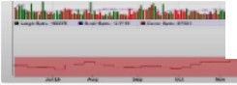

**L:t1 Afnh t:4, d d J.a** ·

' vi

· ::-

**L- +Mr+ 4 Ht+ *t*** §

**tM.11 • .d _ -tML •**

, .

--·--- -- -- --

00

|  |  |  |  |  |  |  |  |
| --- | --- | --- | --- | --- | --- | --- | --- |
|  | | | | | | | |
| * **Op·0.1188350,**=**Hi:.O 889350,**=**Lo:O 872850, CtO 881750** L0200 | | | | | | | |
| **1.010000** | | | | | | | |
| **1.000000** | | | | | | | |
| **0.990000** | | | | | | | |
| **09"0000** | | | | | | | |
| **0.970000** | | | | | | | |
| **0.960000** | | | | | | | |
| **0.950000** | | | | | | | |
| **O.!MOOOO** | | | | | | | |
| **09JOOOO** | | | | | | | |
| **0.920000** | | | | | | | |
| **0.910000** | | | | | | | |
| **0900000** | | | | | | | |
| **0 890000** | | | | | | | |
| ilm£il | | | | | | | |
| **0870000** | | | | | | | |
| **0.800000** | | | | | | | |
| **0.850000** | | | | | | | |
| **0.840000** | | | | | | | |
| **0830000** | | | | | | | |
| F-■ 1.a,- •c5pec""""". -n 8JO=' ■ Sma1 5pec- . = =. eo-- 5pec- 107213=,,, =-i0820000 | | | | | | | |
| **150000** | | | | | | | |
| **100000** | | | | | | | |
| **50000** | | | | | | | |
| **16 Feb** - | - - | **Jun** | **Jul** - - | **0d** - | **Dec** | **.Jon 17** | **·100000** |

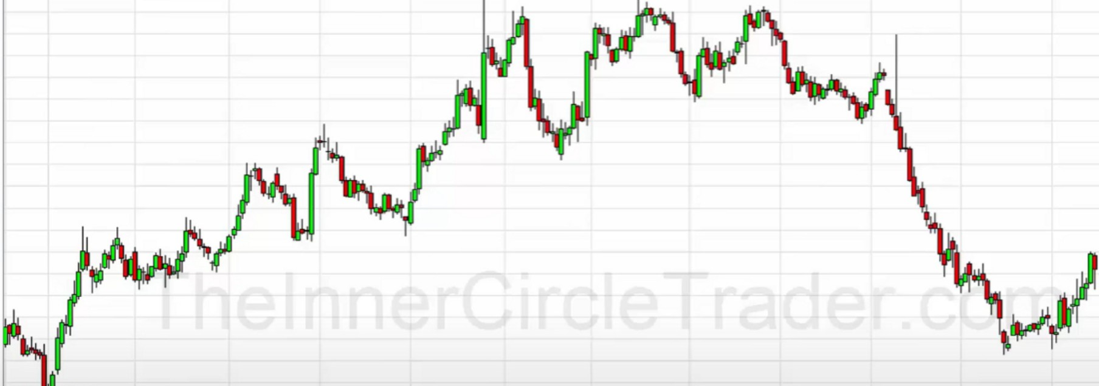

---- -----+---------

**·50000**

We dont restric ourselvers to only selling below the O line and buying above the O line, we can do both. The way to decipher it is by looking at institutional orderflow